3GPP TSG-RAN WG4 Meeting #119 R4-2606908
Dalian, China, May 18-22, 2026

Agenda Item: 8.10.4
Source: Ericsson
Title: 6G ISAC on: “Coexistence study and simulation assumptions”
Document for: Approval

1 Introduction
In the RAN4 meeting #118bis the work plan for 6G sensing in R4-2604941 was approved. There the coexistence study and simulation assumptions are outlined, and objective is to compare first results in RAN4 #120 meeting (October 2026). To compare the results, the scenarios and parameters need to be agreed in this meeting. The scenario may include typical urban/suburban deployments for the around 4 GHz (and other FR1/FR2-1 TDD frequency bands as in WF agreed) and for rural more ISAC centric deployment. The performance metrices need also discussion and agreement in the meeting.
In this contribution we provide additional detailed information of simulation parameters relevant for BS centric ISAC deployment scenarios with the intention to further progress the work required for the co-existence evaluation part of the SID objective.

2 Coexistence study and simulation assumptions

2.1 Scenarios in WF for ISAC
In the WF for ISAC, [1], for the first coexistence studies the following sensing modes, sensing targets and sensing tasks are suggested:
- UAV (passive object), TRP monostatic and TRP-TRP bistatic
  - FFS on Multiple TRP monostatic.
- Vehicle (passive object), TRP-UE bistatic
- [TBD] (passive object), UE-TRP bistatic

The WF further suggests:
Agreement for the prioritized bands to be investigated for 6G sensing
- FR1 TDD bands +FR2-1 TDD bands;
- Encourage inputs from the operators for the bands;

Agreement:
- RAN4 to use the same 6GR BS and UE assumptions for 6G sensing study as starting point;

2.2 Scenarios for BS monostatic and BS-to-BS bistatic sensing
The scenarios for UAV and BS mono-static and BS-to-BS bi-static and possible challenges are outlined in Figure 2.2-1. The legacy TDD operating with only Mobile Broadband (MBB) as the aggressor and sensing as the victim are the more challenging cases. This is because we expect ISAC to follow the MBB timeslot allocation in TDD operators synchronized bands with Compatible frame structure to align uplink/downlink switching points.
- The self-interference/intra-site and inter-site co-channel interference (multiple BSs) is discussed in feasibility studies and needs to be also considered in the coexistence simulation to understand the combined impact.

MBB as aggressor, Sensing as victim | Sensing as aggressor, MBB as victim
BS Monostatic sensing
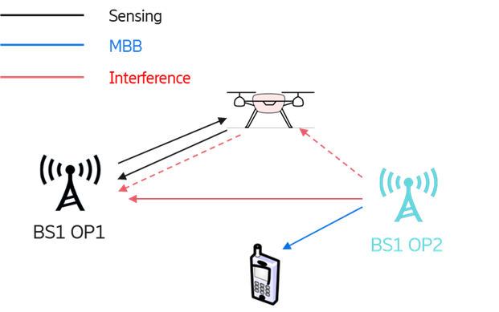  BS1 OP1 (Operator 1) transmits a sensing signal within a DL slot in which BS1 OP2 (Operator 2) transmits MBB traffic. The direct interference link between BS1 OP2 and BS1 OP1 is transmitted at high power, with potentially Line of sight (LoS) conditions, and its impact needs to be understood. In addition, the impact of in-band blocking at the BS1 OP1 receiver should be discussed and understood. Aspects like self-interference/intra-site and inter-site co-channel interference should be also considered in the feasibility study. | 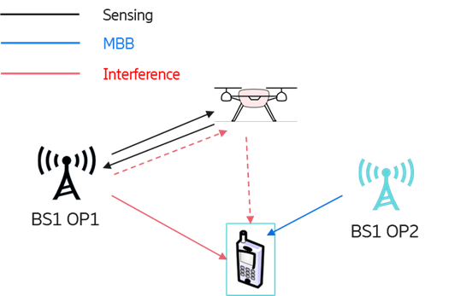  The sensing reference signal is transmitted by BS1 OP1 in a DL slot, so that the ACI to the MBB operator is co-link and not expected to be more challenging than a DL to DL ACI generated in communication-to-communication coexisting deployments.
BS-BS Bistatic sensing
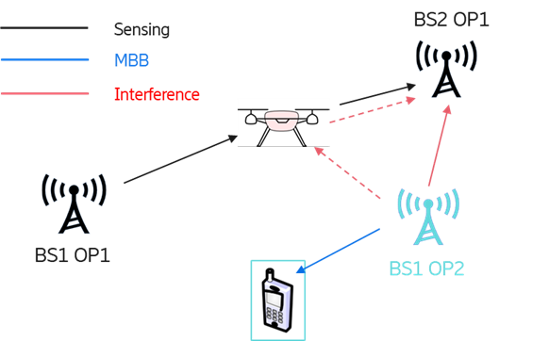The same considerations as for the monostatic sensing hold also in this scenario, since BS2 OP1 needs to act as a sensing receiver during a DL slot.  The direct interference between BS1 OP2 and BS2 OP1 is transmitted at high power, with potentially LoS conditions, and its impact needs to be understood. In addition, the impact of in-band blocking on BS2 OP1 receiver should be also understood. The impact of interference from the reference path or from other sites of the ISAC network should be also studied. | 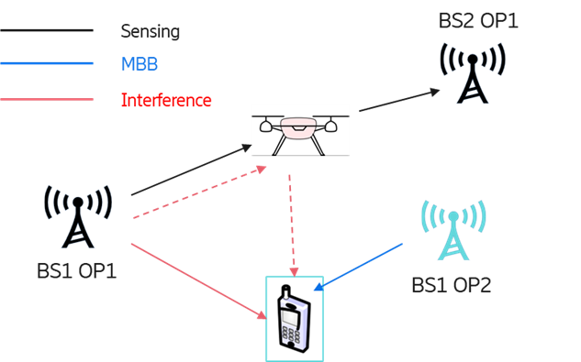  The same considerations as for monostatic sensing hold for this sensing mode. The ACI to be studied is DL to DL interference, and so is not expected to be more challenging than for legacy communication-to-communication coexistence scenarios.
Figure 2.2-1: Sensing scenarios for BS monostatic and bistatic with UAV target.
The network layout for UMa/SMa when studying the coexistence is shown in Figure 2.1-2 considering the urban cases. In the coexistence simulation multiple BSs (legTDD and ISAC) are used (grid of 19 BSs with 3-sectors per BS).
- UMa network layout with hexagonal grid, 19 macro sites and 3 sectors per site for victim and interferer (simplified with sectors boresights from both operators in same direction). Overlapping cell grids with cell shift: 0%, 10%, 50% and 100%. For the colocation there is ongoing work in Rel-20 BS RF evolution WI to define relevant assumptions. Cell loads for the interferer with: 10%, 50% and full buffer. Full buffer is the reference case for legacy TDD BS operation and conformance tests, for the new feature with ISAC operation at lower load situations in the network and the sensing performance requirements needs still be defined and understood.
The legacy TDD and ISAC rural case may need a different network layout for the coexistence studies.
- Further discussion is needed on how rural area legacy TDD and ISAC scenario may look like considering that legacy TDD spectrum around 3.5 GHz is not very common in rural areas.
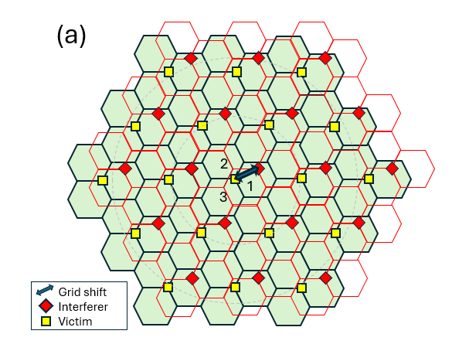
Figure 2.2-2: Interference scenario for (a) UMa/SMa

2.3 Parameters
For the first coexistence studies FR1 TDD bands and FR2-1 TDD bands are prioritized, [1]. For a starting point to use same 6GR BS and UE assumptions for 6G sensing study, [1]. The frequency bands 4 400-4 800 MHz, 7 125-8 400 MHz (or parts thereof), and 14.8-15.35 GHz are currently studied for the terrestrial component of IMT, [2]. The antenna configuration for AAS as used for the 4 GHz and 7 to 8 GHz bands studies in ITU-R for WRC-27 differ, [3]. Further differences are ACLR and ACS, and other assumptions like noise figure. Therefore, coexistence needs to be evaluated in both frequency ranges. The tables below list the network layout and parameters for the frequency around 4 GHz.
- Use for the 4 GHz UAV and BS-to-BS bistatic and BS monostatic the parameters from the Table 2.2.1-1a to Table 2.2.1-1e and Table 2.2.2-1b

2.3.1 Parameters for BS-to-BS bistatic sensing and UAV object with UMa/SMa cell layout and carrier frequency around 4 GHz

Table 2.3.1-1a Network layout and system parameters
Parameters | Value
Frequency and bandwidth | 4 GHz (covering the 3-4 GHz range) with 100 MHz bandwidth
Network layout | UMa/SMa: hexagonal grid, 19 macro sites, 3 sectors per site with wrap around (or victim centre sector)
Inter-site distance | 0.45 km (urban) and 0.9 km (suburban)  Table 4.2.1.1-1 in TR 38.921
Multi operator’s layout | UMa/SMa: 0%, 10%, 50% and 100% grid shift
TDD DL/UL ratio | 80/20%
Synchronised/unsynchronised TDD operation in multi-operator context | Compatible frame structure to align uplink/downlink switching points. ISAC can use DL time slot for transmitting and receiving sensing signals
Cell load | UMa/SMa interferer: 10%, 50% and full buffer

Table 2.3.1-1b BS parameters (mainly from Section 4.2 and 4.4 in TR 38.922)
Parameters | Value
BS power TRP | 49, 53 dBm
BS antenna height | UMa/SMa: 25 m
Antenna mechanical tilt | UMa/SMa: 6 degrees downtilt
AAS antenna elements | Table 4.4.1.2-1 in Reference TR 38.922  (for starting point)
ACLR/ACS | 45/46 dB

Table 2.3.1-1c UE parameters (mainly from Section 4.3 in TR 38.922)
UE Parameters | Value
Outdoor/indoor | Outdoor and indoor with 20/80%
Antenna | 1Tx/2Rx
Antenna gain | Isotropic: 0 dBi
Max Tx power | 23 dBm
Power control | Section 9.1 TR 36.942
SNR target | 15 dB
Noise figure | 9 dB
Antenna height | 1.5 m for outdoor
Distribution (horizontal) | Uniform
Minimum BS - UE distance (2D) | 35 m  For Uncoordinated deployment, minimum distance applies also to UEs and BS across different deployments.

Table 2.3.1-1d UAV parameters
Parameters | Value
UAV distribution | Uniform distribution with heights 25 to 300 meters  (TR 38.901 / TR 36.777)
Minimum BS - UAV distance | 10 meters 3D (TR 38.901 / TR 36.777)

Table 2.3.1-1e Channel models
Parameters | Value
BS-UE channel model | UMa (Table 7.4.1-1 in TR 38.901)
BS-BS channel model | UMa TR 38.901. LoS model is the default defined for UMa  For BS-to-BS interference Line of Sight (LoS) probability with 100% or FSPL
BS-UAV channel model | Rel-19 extensions for ISAC in TR 38.901  - Focusing on large scale parameters  - RCS of the sensing target, the model captured in clause 7.9.2.1

2.3.2 Tables for BS monostatic sensing and UAV object with UMa/SMa cell layout and carrier frequency around 4 GHz
Same Tables as in Section 2.3.1 can be used for the coexistence simulation, beside the table for the BS parameters where the parameters are given in Table 2.3.2-1b for the BS monostatic case.
- Separate antenna panels for Tx and Rx which may have different numbers of antenna elements.
- Lower output power of BS in order to allow for full-duplex operation

Table 2.3.2-1b BS parameters (mainly from Section 4.2 and 4.4 in TR 38.922)
Parameters | Value
BS power TRP | 37, 52 dBm  (for Tx, Rx antenna isolation of 65, 80 dB respectively)  (TR 38.765)
BS antenna height | UMa/SMa: 25 m
Antenna mechanical tilt | UMa/SMa: 6 degrees downtilt
AAS antenna elements | Table 4.4.1.2-1 in Reference TR 38.922  (for starting point)
ACLR/ACS | 45/46 dB

2.4 Simulation results and performance criteria’s
From general radar and sensing theory it is known that the SNR/SINR depends on the following factors:
- System parameters: Transmit power, antenna gain, wavelength, pulse width, receiver NF and BW, etc.
- Signal processing and operational parameters: Number of pulses and pulse integration, coherent/noncoherent processing, waveform design, etc.
- Environment and target parameters: Radar cross section, range-to-target, clutter and interference, etc.
From detection theory e.g. Marcum's Q-Function, [4], and tracking accuracy, Cramer-Rao Lower Bound (CRLB), the SNR/SNIR can be computed and with this the detection and tracking accuracy. The result depends on the factors given above and some especially the “signal processing and operational parameters” will differ largely depending on implementation. For a ISAC receiver, the SNR will increase when integrating the received pulses with Gain = Number of pulses (Assuming white noise). Adaptive signal processing can be used to adapt to the interference situation (low/high) and number of integrated pulses. Integrating over a larger number of pulses also increases the range migration.
In RAN4 the simulation results should be compared and for this the sensing with single pulse is one of the baselines which can be used.
- Single pulse as baseline to compute SINR
- The simulation results should compare the SINR CDFs with and without interference
- Sensitivity analysis for detection and tracking accuracy considering number of pulses and pulse integration for different interference level low/high situations
- Detection probability versus SINR is needed to define acceptable SINR threshold value

Conclusion
The following is proposed for the ISAC WF on “Coexistence study and simulation assumptions”:
Proposal 1: The self-interference/intra-site and inter-site co-channel interference (multiple BSs) is discussed in feasibility studies and needs to be also considered in the coexistence simulation to understand the combined impact.
Proposal 2: UMa network layout with hexagonal grid, 19 macro sites and 3 sectors per site for victim and interferer (simplified with sectors boresights from both operators in same direction). Overlapping cell grids with cell shift: 0%, 10%, 50% and 100%. For the colocation there is ongoing work in Rel-20 BS RF evolution WI to define relevant assumptions. Cell loads for the interferer with: 10%, 50% and full buffer. Full buffer is the reference case for legacy TDD BS operation and conformance tests, for the new feature with ISAC operation at lower load situations in the network and the sensing performance requirements needs still be defined and understood.
Proposal 3: Further discussion is needed on how rural area legacy TDD and ISAC scenario may look like considering that legacy TDD spectrum around 3.5 GHz is not very common in rural areas.
Proposal 4: Use for the 4 GHz UAV and BS-to-BS bistatic and BS monostatic the parameters from the Table 2.2.1-1a to Table 2.2.1-1e and Table 2.2.2-1b
Proposal 5: Single pulse as baseline to compute SINR
Proposal 6: The simulation results should compare the SINR CDFs with and without interference
Proposal 7: Sensitivity analysis for detection and tracking accuracy considering number of pulses and pulse integration for different interference level low/high situations
Proposal 8: Detection probability versus SINR is needed to define acceptable SINR threshold value

References
- R4-2605009, “Way Forward for [118bis][362] 6G_Sensing”, ZTE Corporation, Meeting #118bis, April 13 - 17, 2026.
- RESOLUTION 256 (WRC-23), "Sharing and compatibility studies and development of technical conditions for the use of International Mobile Telecommunications (IMT) in the frequency bands 4 400-4 800 MHz, 7 125-8 400 MHz (or parts thereof), and 14.8-15.35 GHz for the terrestrial component of IMT", The World Radiocommunication Conference (Dubai, 2023).
- 3GPP TR 38.922, “Study on International Mobile Telecommunications (IMT) parameters for 4400 - 4800 MHz, 7125 - 8400 MHz and 14800 - 15350 MHz”, V19.3.0 (2025-12)
- M.I. Skolnik, ”Radar Handbook”, 3rd Edition, 2008

